In The Land Of Restaurant Sales, Wine Is King
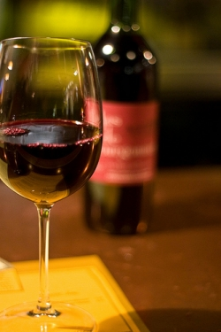
One of the most intimidating obstacles facing new servers, is learning about wine. Unfortunately, as a server, the absolute best way to increase your sales (and your tips), is to sell more wine.
Most restaurants only give servers a basic understanding of wine as part of their initial training, they don't really get into the intricacies, and varieties of wine. In this guide, we'll cover everything you need to know to, not only understand wine, but to sell it effectively to your guests.
This guide is written for servers, and any server that's serious about making more money should definitely keep reading, however it's also useful for restaurant managers, and owners, who want to train their staff to better interact with their customers when it comes to wine sales.
By reading this guide, and implementing the tips and techniques it contains, I guarantee you you can add hundreds of dollars a night to your sales. These are the same techniques I used for years as a server, and they are proven effective in almost any restaurant.

