Caption for photograph number one. Place your text in this position.

**Wine Awakenings.COM**

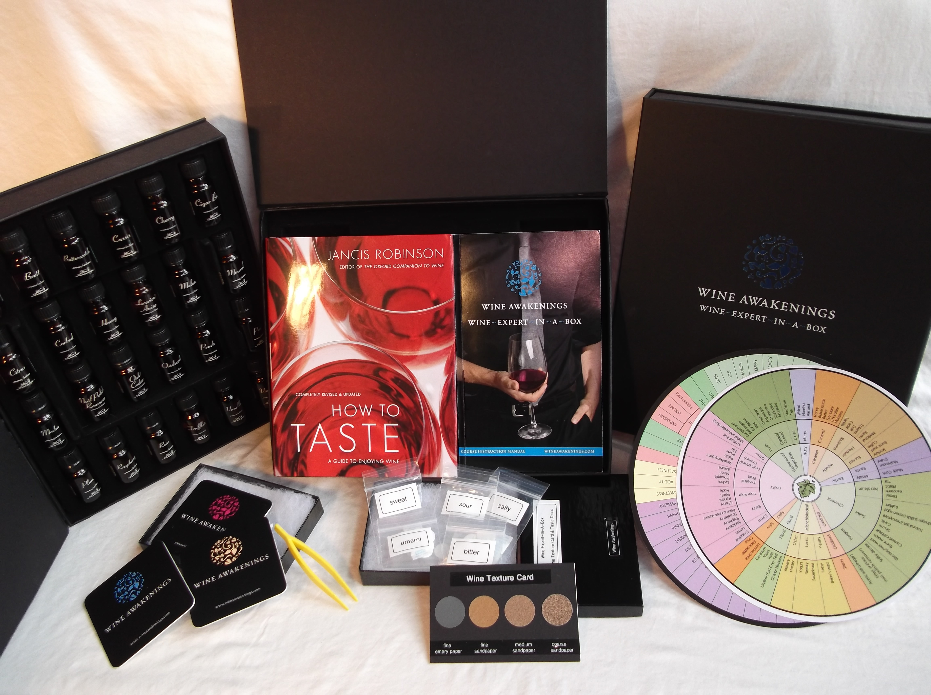



**The beautifully packaged WINE AWAKENINGS WINE~EXPERT~IN~A~BOX**™ **course recreates the total “wine experience”. License and materials contained:**

* ***Course Manual*** – an 80 page course pack to guide the participant through the self-paced study program
* A ***set of 24 aromas*** representing the most encountered aromas found in Cabernet Sauvignon, Chardonnay, Pinot, Red, White and Wine Faults
* The “***How to Taste***” book by Jancis Robinson
* Wine Wheels: The ***Mouthfeel Wheel***™ and ***Wine Aroma Wheel***™
* ***Wine Texture Card***™: To recreate the “feel” of wine
* ***Taste Discs***: Sour, Sweet, Bitter, Salty & Umami
* **Plastic tweezers** for use with the Taste Discs
* **Key topics covered include**: getting to know one’s palate, the basic components of taste and flavour, “nosing” red and white wines, the feel of wine, wine faults, the complex matrix of wine, pitfalls of tasting and the art of the service.

**WINE AWAKENINGS**



hhhhhhh

**World premiere**

WINE AWAKENINGS introduces the new standard in wine education.

**WINE AWAKENINGS** is a dynamic Canadian company, taking "leisure education" to a whole new level. This month, the company is **introducing *another first*: Wine~Expert~in~A~Box** because wine deserves not only to be consumed, but appreciated and understood. This unique program containing patented technology will enable the participant to scientifically understand wine’s distinctive characteristics; to speak with confidence; either for commercial application within the hospitality industry or for personal enrichment.

To create this most unique tool, their oneological experts have carefully researched, selected and adapted the very best existing wine education resources and created some new and unique sensory based tools that will recreate the “total wine experience” in a virtual classroom environment. The participants’ progress will be guided and carefully charted to ensure that they are fully supported and personnaly coached throughout the program. The course makes use of the latest proven “distance learning” techniques.

“Why pay thousands of dollars to learn wine appreciation…now you can earn a certificate for far less and in the comfort of your own home at your pace” said Amato De Civita, President of **WINE AWAKENINGS** “this is a bold new step towards demystifying the world of wine for all to enjoy”.

Upon completion an official **Certificate of Achievement in Advanced Wine Appreciation** is issued directly to the participant.